Experiment 03 - Git Commands

| Roll No. | 37 |
| --- | --- |
| Name | Mikil Lalwani |
| Class | D15-B |
| Subject | DevOps Lab |
| LO Mapped | LO1: To understand the fundamentals of DevOps engineering and be fully proficient with DevOps terminologies, concepts, benefits, and deployment options to meet your business requirements  LO2: To obtain complete knowledge of the “version control system” to effectively track changes augmented with Git and GitHub |
|  |  |

**Aim**: To Perform various GIT operations on local and Remote repositories using GIT Cheat-Sheet

**Introduction**:

1. git config --global user. name “[firstname lastname]” - set a name that is identifiable for credit when reviewing version history
2. git config --global user.email “[valid-email]” - set an email address that will be associated with each history marker
3. git init - initialize an existing directory as a Git repository
4. git clone [url] - retrieve an entire repository from a hosted location via URL
5. git log - show the commit history for the currently active branch
6. git log branchB..branchA - show the commits on branchA that are not on branchB
7. git log --follow [file] - show the commits that changed file, even across renames
8. git diff branchB...branchA - show the diff of what is in branchA that is not in branchB
9. git status - show modified files in working directory, staged for your next commit
10. git add [file] - add a file as it looks now to your next commit (stage)
11. git reset [file] - unstage a file while retaining the changes in working directory
12. git diff - diff of what is changed but not staged
13. git diff --staged - diff of what is staged but not yet commited
14. git commit -m “[descriptive message]” - commit your staged content as a new commit snapshot

**Just getting started – GitHub**

Just using GitHub, please complete each task below. This requires that you have already set up an account.

| Change your profile picture and name | Go to settings in your github account and change your name and profile picture |
| --- | --- |
| Create a repository named GitHubExpt03_grno | Click on the plus icon present on the right side and select create new repository and provide a name |
| Create a file in the above directory named “intro.txt” with your name on the first line. | Click on add a new file and name it and write your name and click on commit the changes |

To show ALL of above in one screen, you should be able to go to the URL (or close):

https://github.com/Mikil03/GitHubExpt03_37

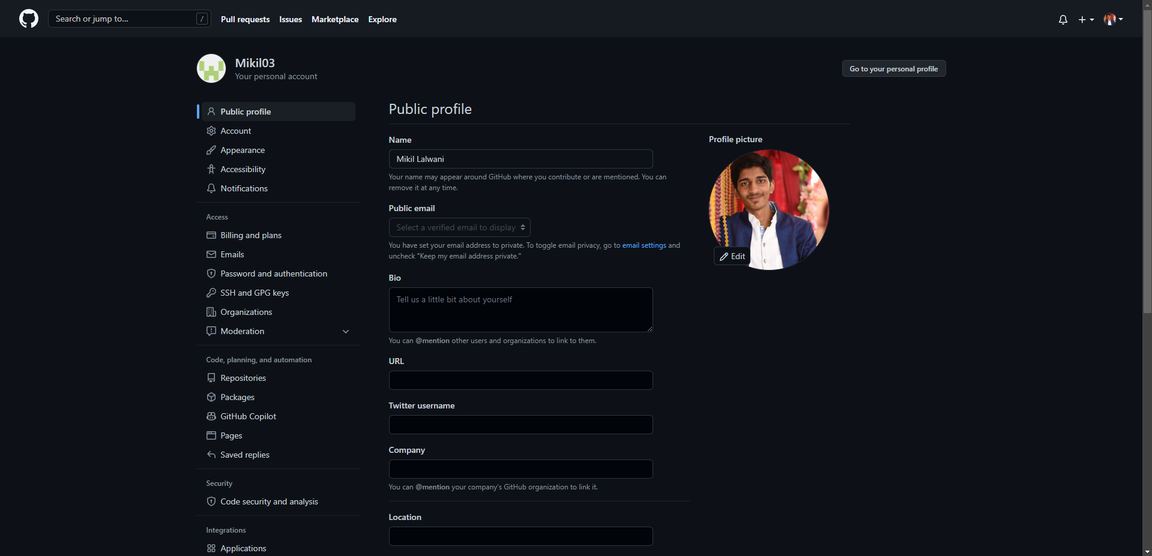

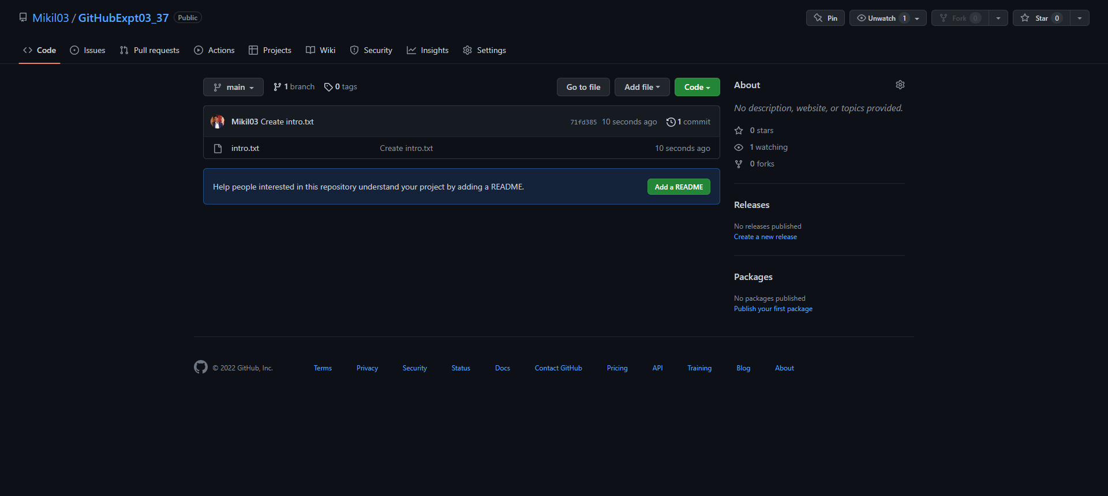

**Just getting started – Git Bash**

Just using Git, please complete each task below and write the answer in the blank box beside the question. This requires that you have already installed Git.

| setup user name (Please use your given name) | Git config –global user.name “<user name>” |
| --- | --- |
| setup user email (Please use your ves account) | Git config –global user.email “<user email>” |
| Create your local repository named GitExpt03_grno | Mkdir GitExpt03_grno  Git init |
| Add a file in above local repository named file_grno_rollno and add some content to file  Add it to staging state | Git add <filename> |
| Commit the files | Git commit -m “<commit message>” |
| Create a scenario for modifications/additions of the multiple files. Show the advantage of staging state. | Git add .  Git commit -m “<commit message>” |
| Display the log | Git log |
| Download your GitHub repository created in table-1 named GitHubExpt03_grno | Git clone “<url of repo>” |
| Make some changes in the GitHub file.  Pull the latest files from your GitHub repository | Git pull |
| Make some changes in the local file of GitHub repository  Update the changes back to Github Repository | Git add .  Git commit -m “<commit message>”  Git push |

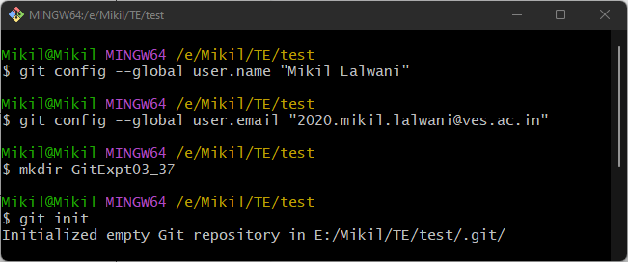

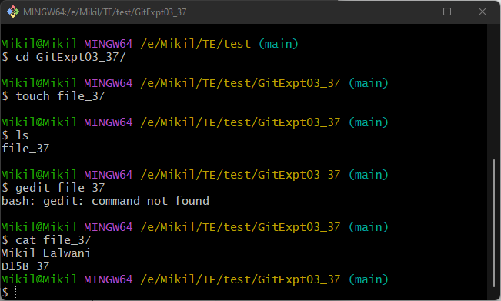

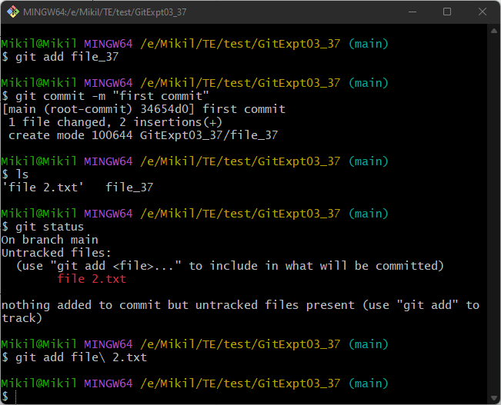

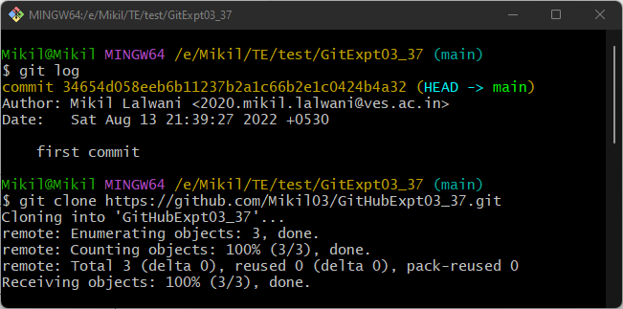

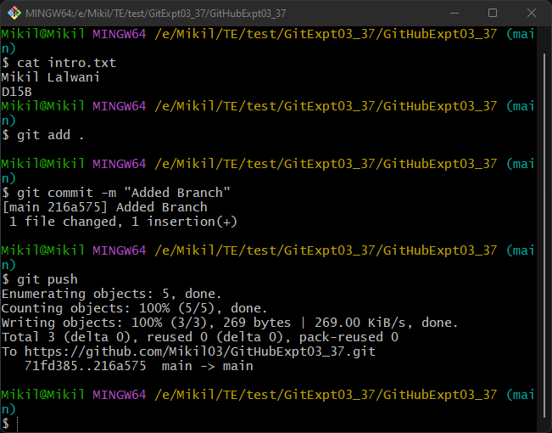

**Team set up in GitHub**

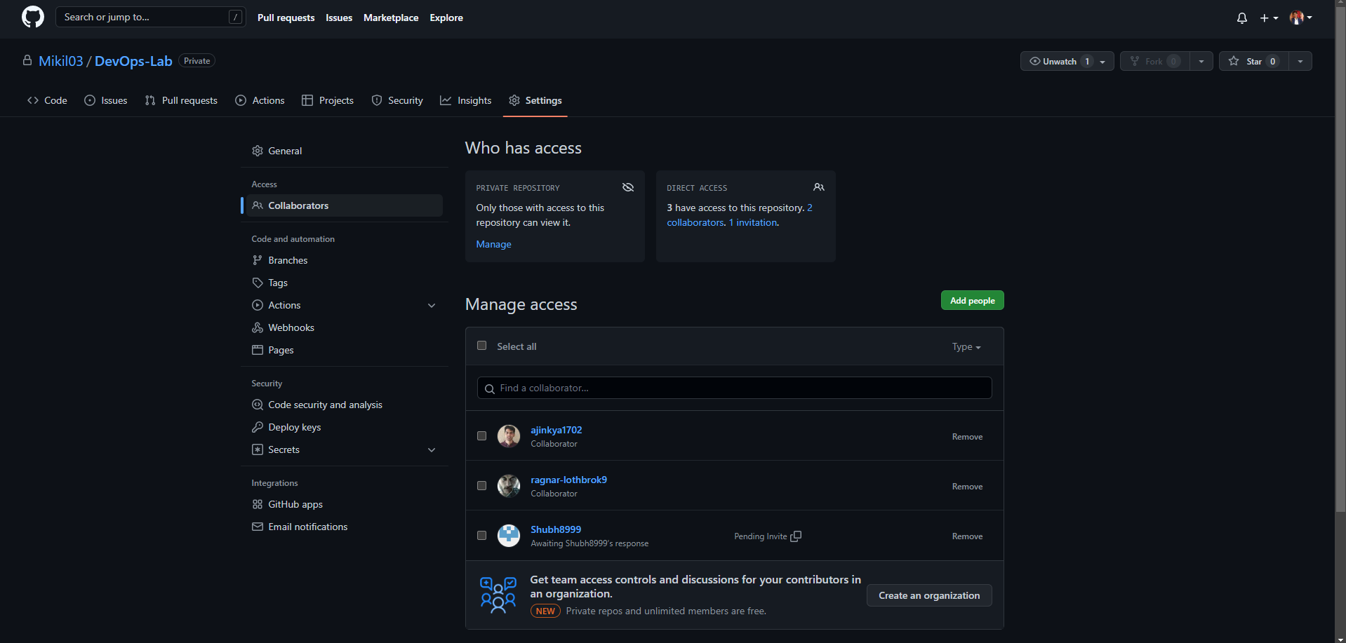

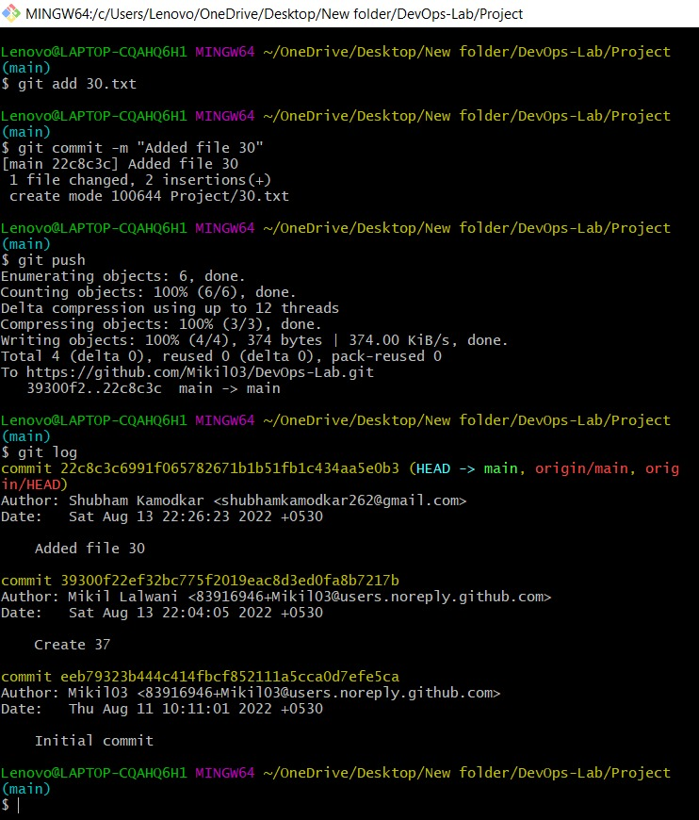

**Conclusion**

Successfully performed the experiment.